Ideation Phase
Define the Problem Statements

Date | 3 July 2026
Team ID
Project Name | Comprehensive Analysis and Dietary Strategies with Tableau: A College Food Choices Case Study
Maximum Marks | 2 Marks

Customer Problem Statement Template:
Create a problem statement to understand your customer's point of view. The Customer Problem Statement template helps you focus on what matters to create experiences people will love.
A well-articulated customer problem statement allows you and your team to find the ideal solution for the challenges your customers face. Throughout the process, you’ll also be able to empathize with your customers, which helps you better understand how they perceive your product or service.


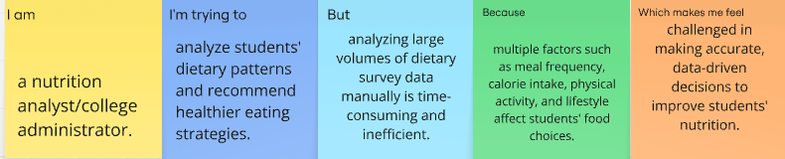
Problem Statement (PS) | I am (Customer) | I’m trying to | But | Because | Which makes me feel
PS-1 | a college student who wants to maintain a healthy lifestyle. | understand my dietary habits and choose healthier food options. | I find it difficult to identify balanced eating patterns and nutritious meals. | my food choices are influenced by busy schedules, limited awareness, and unhealthy eating habits. | confused about my nutrition and concerned about my overall health.
PS-2 | a nutrition analyst/college administrator. | analyze students' food consumption patterns and provide effective dietary recommendations. | analyzing large volumes of student dietary data manually is time-consuming and inefficient. | multiple factors such as calorie intake, meal frequency, lifestyle, and physical activity affect students' health. | challenged in making accurate, data-driven nutrition decisions.

